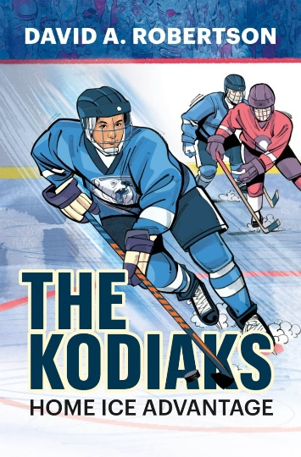

**“The Kodiaks”**

**Art Activity**

The Kodiaks hockey team features a bear as its logo. Design your own hockey jersey below, using a symbol and colours that represent you and your interests!