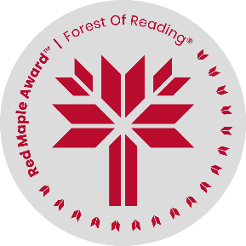Name: ____________________

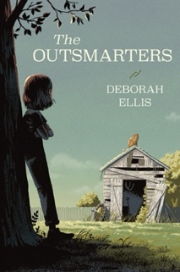

**The Outsmarters by Deborah Ellis**

**Crossword Puzzle**

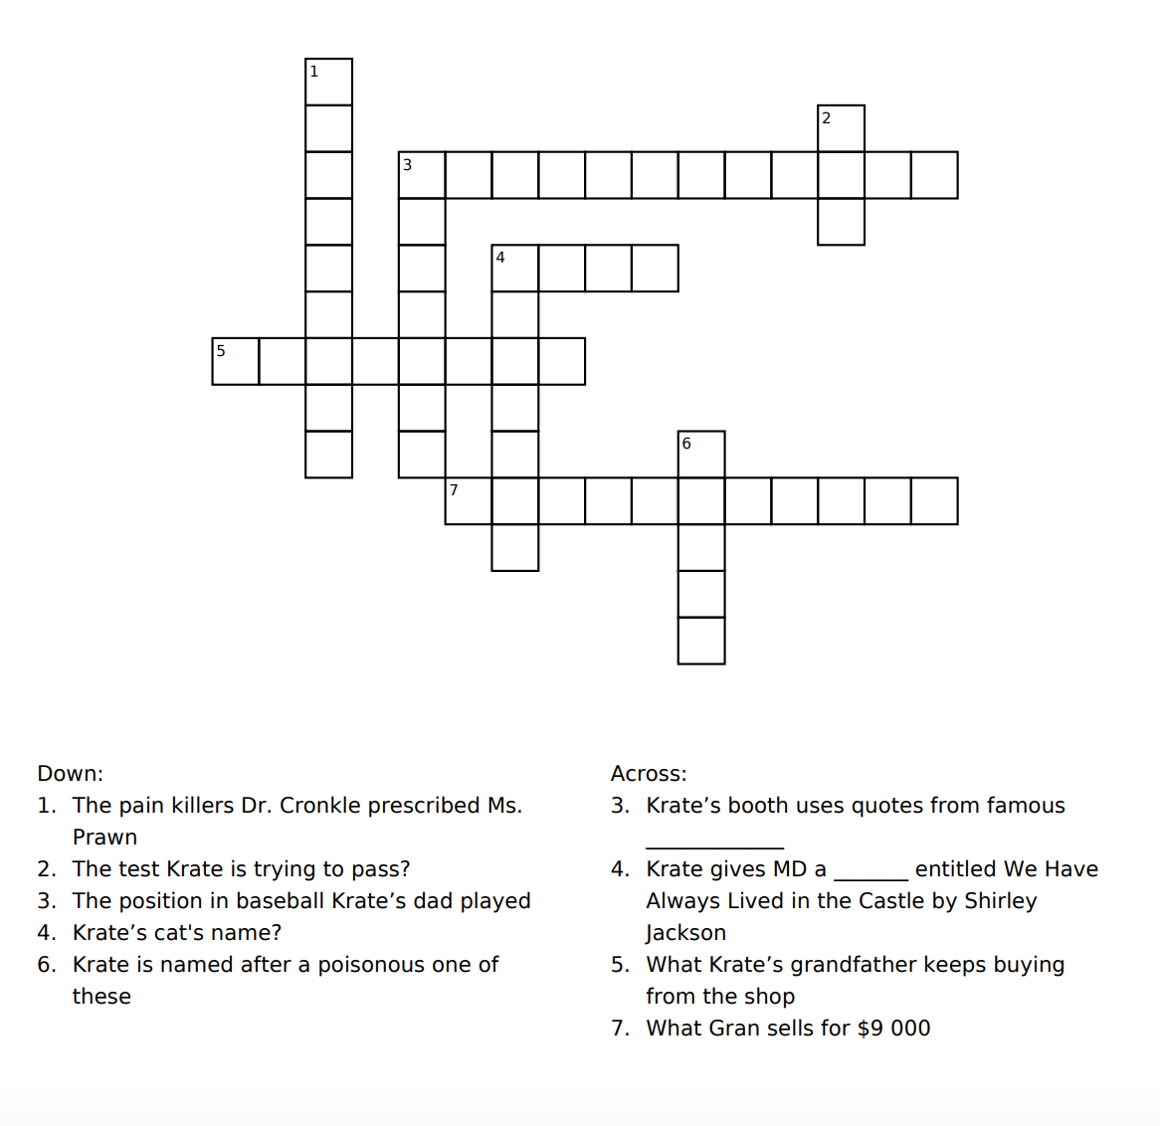

****Name: ____________________



**The Outsmarters by Deborah Ellis**

**Crossword Puzzle – Answer Key**

