**Name: ______________________**

**Little Moons Comic Activity**

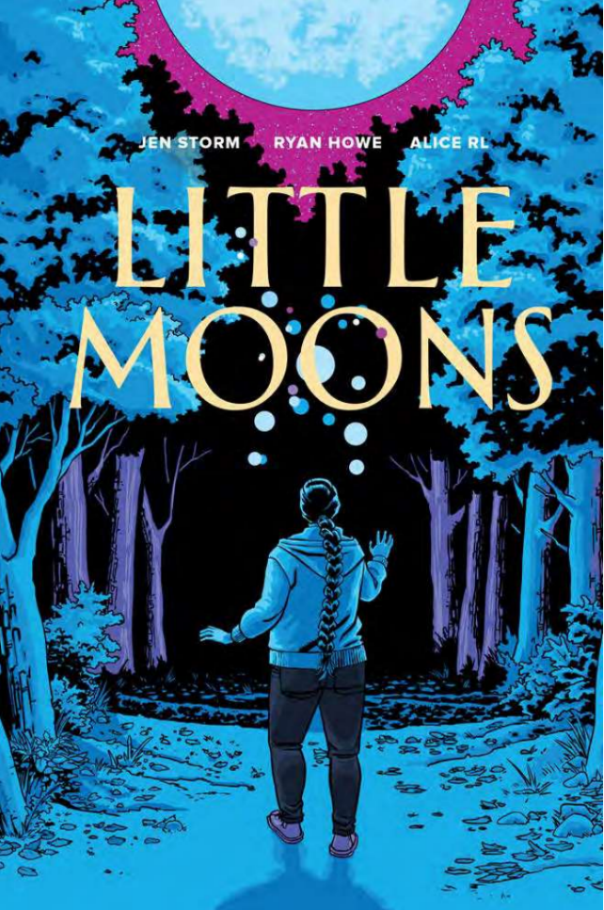

In *Little Moons*, the opening scenes show Reanna’s family and their routine.

On a separate sheet of paper, draw your own 4-panel or 6-panel comic of how you go about your daily routine. You can include what other family members in your household do, or you can choose to focus on your personal routine.

Consider using colour or style of drawing to reflect how you see your world or how you feel at each part of the day.