**Asking for a Friend** 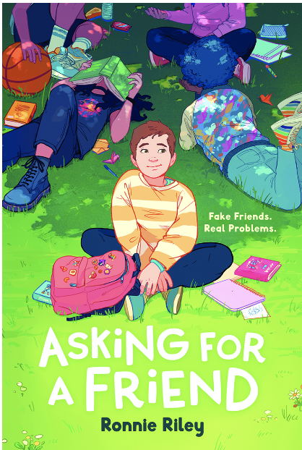

Name: ________________________

Advocacy Letter/Podcast/Video PSA:

Tabitha learns that she will need to be assigned to a new foster family and may need to change schools. Her friends offer to write letters to her caseworker on why she should stay in the same school district.

What does your school or community need? What issue(s) are you passionate about?

Write a letter to your school principal or local government advocating for what you want. Convince the reader that your demands are reasonable and necessary. If you prefer, create a podcast on the topic you have chosen or create a video public service announcement to inform others about the issue.

