Bertie Stewart is Perfectly Imperfect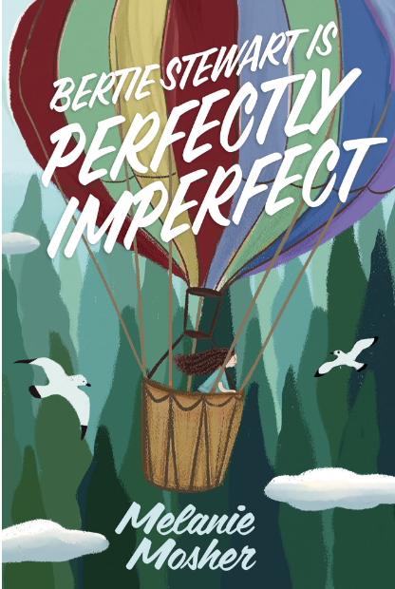

Name: ______________________

**Art & Science Activity: Tree Drawing**

“A tree grows. It doesn’t worry about whether its branches are crooked or messy…it just is. And it is perfect.” (p.47) Bertie loves trees. She finds joy in climbing up high and peace sitting on their branches. Trees represent a simplicity that she sometimes doesn’t feel in her own life.

Research different species of trees from your part of the world. Which kind of tree do you think Bertie might choose if she lived where you do?

On the back of this page, **draw Bertie’s favourite tree in Fountain Park**. Include Bertie in your drawing of her favourite tree - where might she be hanging out?

Tree Research:

