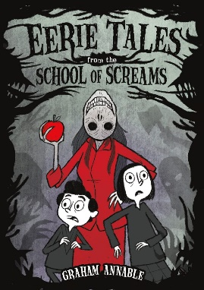Name: _______________________

**Eerie Tales from the School of Screams**

**Graphic Story Activity**

Use the panels below to create your own eerie story. Feel free to add additional pages as needed.