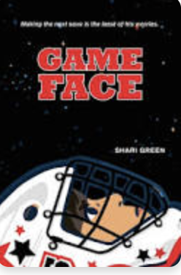 Name: __________

**Game Face - Poetry Writing Activity**

Shari Green uses a shape poem to emphasize the word ‘spin’. This type of poem enables readers to feel a stronger connection to the word(s) or phrase. Using any of the examples from the Art Activity, create a poem that connects the words and images into a shape.

**Examples from the Art Activity**

1. On page 27-8, “for the acrobatics going on in my stomach and the what-ifs rattling a doorknob in my brain, threatening to burst in and ruin everything”.
2. On page 51, "The sound burrows into my brain brings numbers back into focus loosens the band around my chest.”
3. On page 91, “and a cold weight moving through my limbs growing heavy muscle and bone replaced with solid blocks of ice.”
4. On page 97, "It was like a tiny alien creature invaded my brain, took over my controls.”