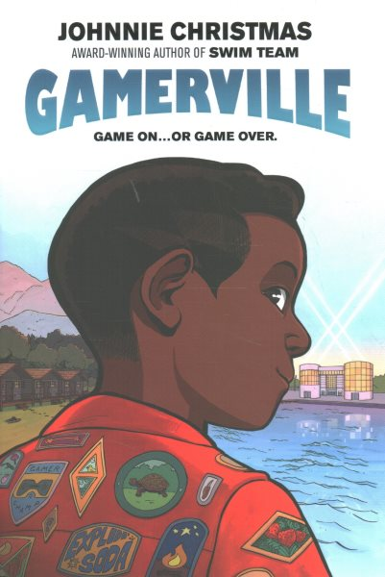Name: ______________________

**Gamerville Letter Writing Activity**

**Campers often write letters to friends and family while attending Summer Camp. Using the space below, write a letter home from one of the characters at Camp Reset.**

**________________________________________________________________________________________________________________________________________________________________________________________________________________________________________________________________________________________________________________________________________________________________________________________________________________________________________________________________________________________________________________________________________________________________________________________________________________________________________________________________________________________________________________________________________________________________________________________________________________________________________________________________________________________________________________________________________________________________________________________________________________________________________________________________________________________________________________________________________________________________________________________________________________________________________________**