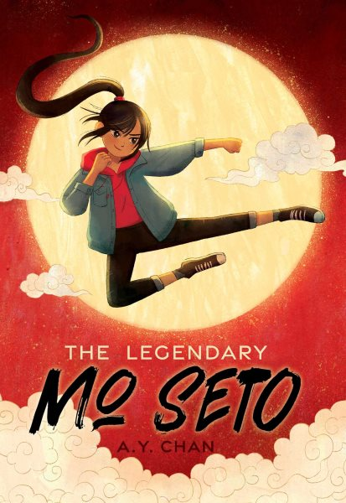 Name: ______________________

**The Legendary Mo Seto**

**Crossword Puzzle Answers**

