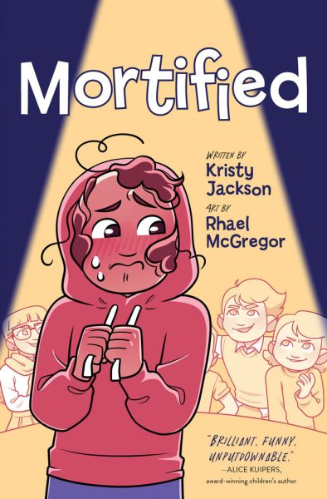

**“Mortified”**

**Discussion Questions**

1. Belinda and her once-close friend Chloe outgrow each other, and she befriends somebody completely different, Sally. Can you relate to this experience? Do you think that we have different friends for different stages of our lives?
2. On page 20, Belinda talks about a Wayne Gretzky quote that Mr. Penney has displayed on a poster: “You miss 100 percent of the shots you don’t take.” Do you have a favourite quote that motivates you?
3. Belinda’s “bunnyhug” – her hoodie – is an item of comfort and security to her. Do you have a favourite item of clothing or something similar that brings you comfort when you are sad or anxious?
4. Belinda auditions for the play after someone puts her name on the sign-up sheet. Have you ever tried something outside of your comfort zone because someone else encouraged or pushed you to do so, like trying out for a sports team or go on an audition?
5. Everyone needs someone in their lives to believe in them and cheer them on. Who would you say are Belinda’s champions in Mortified?