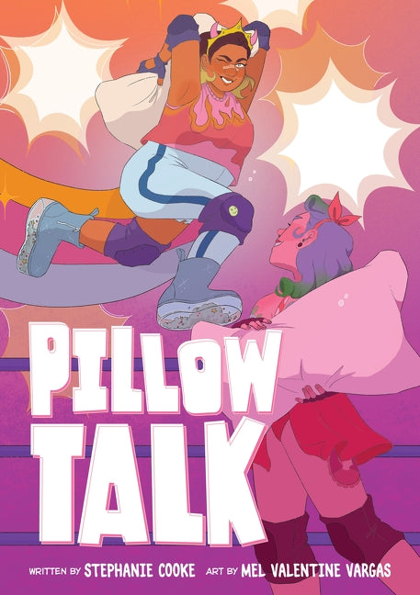

Game Plan

Like other sports, there is a game plan that the players can follow filled with key moves. Using page 91 and your fightsona, create a game plan in the space below to choreograph your signature move.

Use a combination of illustrations and descriptions to make your steps clear in the same way that Stephanie Cooke and Mel Valentine Vargas did. As a bonus, you can give it to a friend to see if they can act it out!