Name:_______________________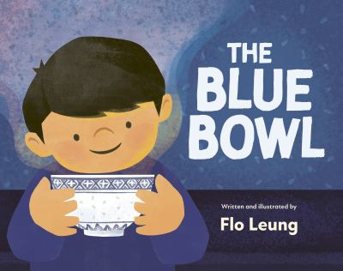

**The Blue Bowl- Birthday Menu Activity**

Max’s birthday feast included delicious traditional Cantonese cuisine with an Italian twist followed by a magical mango cake with rainbow sprinkles! Use the chart below to plan your perfect birthday meal. List what dishes or foods you would like to eat and then draw a picture of what they would look like.

|  | **Name of Food/Dish** | **Picture of Dish** |
| --- | --- | --- |
| **First Course** |  |  |
| **Main Course** |  |  |
| **Dessert** |  |  |