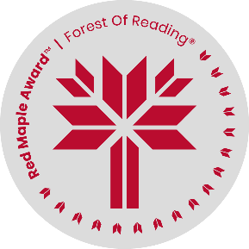 Red Maple Activity: Research Activity

*Why We Play With Fire* by Giselle Vriesen

Name: ______________________________

“’My mother is a jeweler in Ecuador but her father is a messenger god named Bochica, worshipped in Colombia for thousands of years as a bringer of civilization. My grandfather on my father’s side is Tezcatlipoca, god of destiny,’ she says with a wink and a smile.” (Page 44)

Where do your ancestors come from, and what mythologies or religions are associated with them? Choose two mythological or religious figures to research. For each one, note their name, responsibilities, powers, and symbols, and share your favourite story about them. If you were a Godspring of these figures in Malachite, which one do you think you would choose?