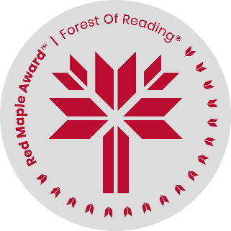
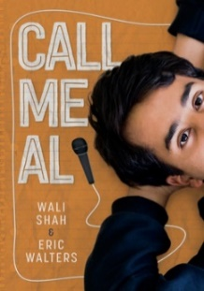
Call Me Al
By Wali Shah & Eric Walters
Create a book cover

You’ve been asked to create a new cover for the book. What colours would you choose? Would you have people or places on the cover? Both? Some type(s) of Pakistani food? Lines of poetry? Use the space below to design your book cover. Use your imagination while keeping with the themes in the book!

