Name:_______________________

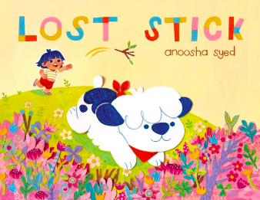

**LOST STICK  
 by Anoosha Syed**

**Discussion Questions**

1. **Why was the park Milo’s favourite place in the world?**
2. **Why was the stick so special to Milo?   
   Why did he make his best effort to find the stick?**
3. **At the same time that Milo was trying to find the stick, what was Louise trying to find?**
4. **Milo searched far and wide for the stick that Louise threw in the park. He searched around his town, in the desert, in the snowy mountains, in the forest, and ventured across the ocean.   
   Could the stick have been thrown that far?   
   Why or why not?**
5. **Did anyone try to help Milo find the stick?  
   How do you feel when your friends help you with a problem?   
   Why is it important to help each other?**
6. **What was Milo’s reaction when he spotted the stick on the dresser?   
   Why did he react that way?**
7. **What would you do if you lost something important? How would you try to find it?**
8. **What would you do differently if you were in Milo’s place?   
   How would you feel if you found someone else’s lost item?**
9. **What can we learn from Milo’s adventure in finding the lost stick?   
   Is it okay to feel upset when we lose something? How should we handle it?**

