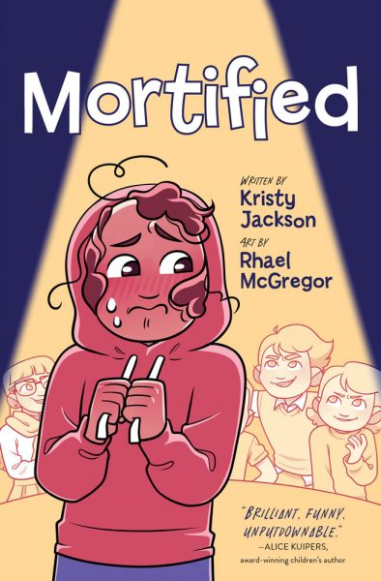

**“Mortified”**

**Art Activity**

Belinda suffers a drastic hair mishap that changes her appearance in a dramatic way.

Use this blank template to conceive of the worst possible haircut you can imagine!

