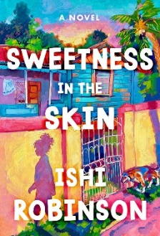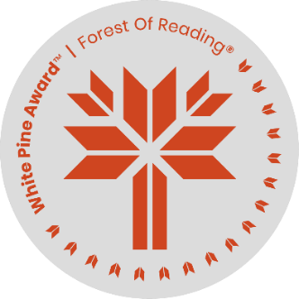

***Sweetness in the Skin***

Discussion questions

Name: _______________________________

1. Before reading Sweetness in the Skin, what did you think it would be about, based on the cover and title?

_______________________________________________________________________________________

_______________________________________________________________________________________

_______________________________________________________________________________________

1. After reading, do you think the cover and title are representative of the book? Why or why not?

_______________________________________________________________________________

_______________________________________________________________________________

_______________________________________________________________________________

1. What was your first impression of the main character, Pumkin? Why do you think her nickname is spelled without the ‘p’ as in pumpkin?

_______________________________________________________________________________________

_______________________________________________________________________________________

_______________________________________________________________________________________

1. Why is it so important to Pumkin’s Gramma and Aunt Sophie that Pumkin be educated and speak well?

_______________________________________________________________________________________

_______________________________________________________________________________________

_______________________________________________________________________________________

1. Why is it so hard for Pumkin’s mother to let Pumkin try to improve herself/her life?

_______________________________________________________________________________________

_______________________________________________________________________________________

_______________________________________________________________________________________

1. How would Pumkin’s life be different if she didn’t have an Aunt Sophie?

_______________________________________________________________________________________

_______________________________________________________________________________________

_______________________________________________________________________________________

1. How did Ms. Keene see herself in Pumpkin and why did she want to help Pumkin?

_______________________________________________________________________________________

_______________________________________________________________________________________

_______________________________________________________________________________________

1. Do you think Tamara did the right thing by telling on Pumkin for selling treats at school? Why or why not?

_______________________________________________________________________________________

_______________________________________________________________________________________

_______________________________________________________________________________________

1. Do you think Pumkin should forgive Tamara once she knows the reason(s) for telling on her? Why or why not?

_______________________________________________________________________________________

_______________________________________________________________________________________

_______________________________________________________________________________________

1. Do you identify with any of the characters in the book? Who and why – or why not?

_______________________________________________________________________________________

_______________________________________________________________________________________

_______________________________________________________________________________________

1. Have you read any book(s) similar to this one? How is this one similar – or if not, how is it different from other books?

_______________________________________________________________________________________

_______________________________________________________________________________________

_______________________________________________________________________________________

1. Come up with an idea for your own pastry or baked good. What would be in it and what would you call it? Or describe your favourite baked good that you know how or want to learn how to make!

_______________________________________________________________________________________

_______________________________________________________________________________________

_______________________________________________________________________________________

**About the Author**

****Ishi Robinson was born and raised in Kingston, Jamaica. She has lived in Bern, Toronto, Rome, and London, and now lives in Berlin with her Czech husband. She has published short stories in several online publications and one anthology. Sweetness in the Skin is her first novel.

Photo credit: Zoe Spawton