Name:_______________________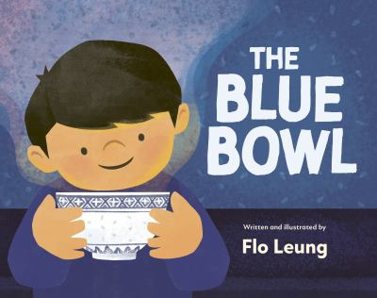

**The Blue Bowl Word Search Answers**

|  | **S** | **P** | **A** | **G** | **H** | **E** | **T** | **T** | **I** |  |  |
| --- | --- | --- | --- | --- | --- | --- | --- | --- | --- | --- | --- |
|  | **S** | **S** | **E** | **L** | **K** | **N** | **I** | **R** | **P** | **S** | **N** |
| **C** | **C** |  |  |  |  |  | **Y** |  | **N** |  | **O** |
| **A** | **A** |  | **B** |  |  | **L** |  | **I** |  | **Y** | **I** |
| **N** | **L** |  |  | **O** | **I** |  | **S** |  |  | **A** | **T** |
| **T** | **L** |  |  | **M** | **W** | **U** |  |  |  | **D** | **C** |
| **O** | **I** |  | **A** |  | **O** | **L** |  |  |  | **H** | **E** |
| **N** | **O** | **F** |  | **C** |  |  |  |  |  | **T** | **N** |
| **E** | **N** | **M** | **A** | **N** | **G** | **O** |  |  |  | **R** | **N** |
| **S** |  |  |  |  | **F** | **E** | **A** | **S** | **T** | **I** | **O** |
| **E** |  |  |  |  |  |  |  |  |  | **B** | **C** |
| **S** | **K** | **C** | **I** | **T** | **S** | **P** | **O** | **H** | **C** |  |  |

**Word List**

Cantonese birthday chopsticks

bowl cousins sprinkles

spaghetti mango scallion

feast connection family