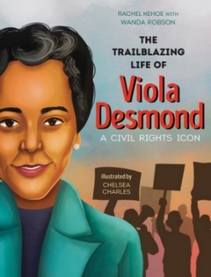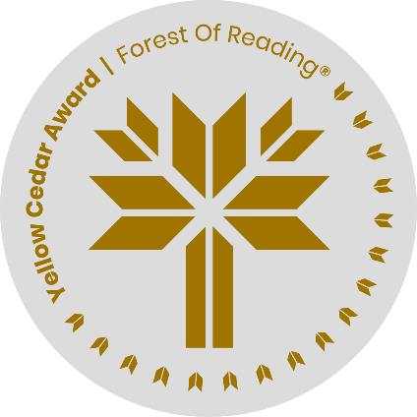

**The Trailblazing Life of**

**Viola Desmond**

*Drawing Activity*

For Viola Desmond, her family and her community were very important. She fought for civil rights, for equality and for education.

Imagine you are attending a parade to honour Viola Desmond while she is still alive. Design a flag or a poster that you would wave as she goes by in the parade. Would it be colourful? Would it include a picture of a school? Of a family (your family?) What words would you include? (e.g. Justice? Equality? Civil Rights? Something else?). Be creative!