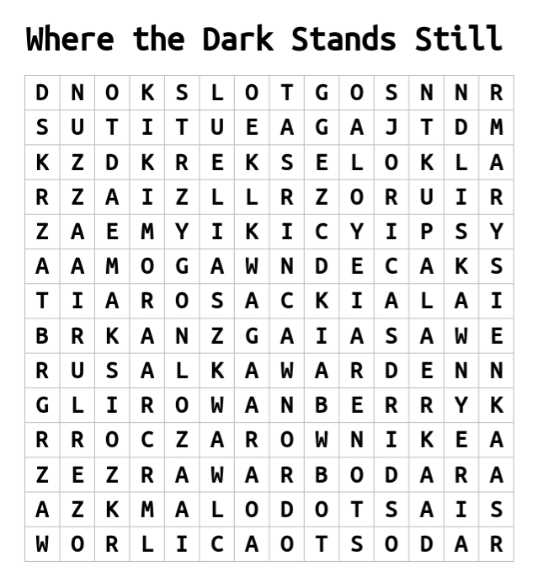

|  |  |  |  |  |
| --- | --- | --- | --- | --- |
| Rusalka | Jaga | Marysienka | Orlica | Maksio |
| Warden | Rowanberry | Kikimora | Radost | Liska |
| Leszy | Strzygon | Kupala | Dobrawa |  |
| Stodola | Eliasz | Czarownik | Skrzat |  |

