**Asking for a Friend** 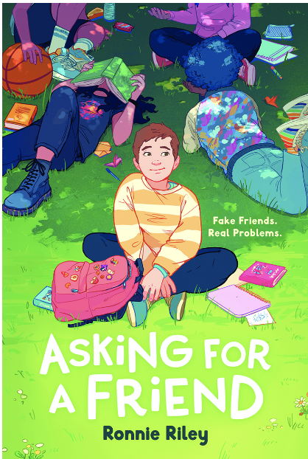

Name: ________________________

**Mindful Activity: Origami**

Eden gets to know their new friend Tabitha when she teaches Eden how to make origami hummingbirds. Origami is a very mindful activity which might calm an anxious mind. Find a book in your school or public library (or use an online resource) with instructions for folding an origami bird. Write out the instructions in the space below. Diagrams of the folds often help, too. Fold the bird - then teach a friend to make one!

