**Gorgeous Gruesome Faces**

**Author Letter**

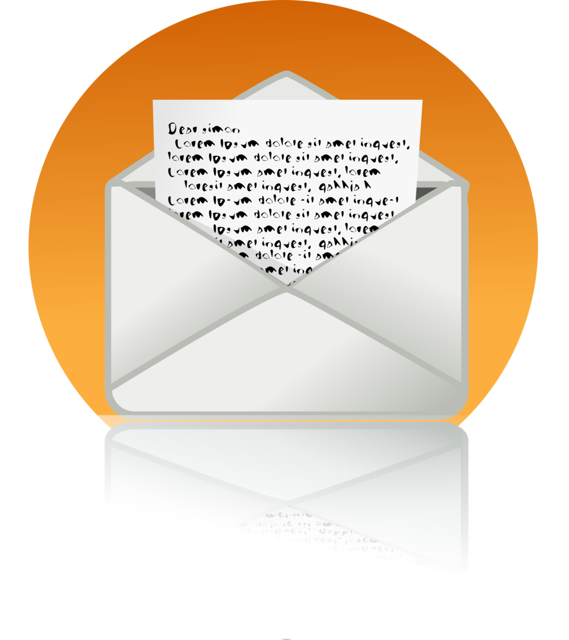

Authors love to hear from their fans. It is a way to stay connected and see what the readers think of their work. Young adult fiction writers especially like hearing from the readers to see the impact their books have had.

**Your Task:**

1. Write a letter to the author that shows your reaction to the book.
2. Include all the elements of a friendly letter. (Date, greeting, body, closing and signature).
3. Give your opinion of the story and reasons for the opinion you have. Be honest!!
4. Discuss one character you are most like and why.
5. Explain your favourite part of the story and why.
6. Ask the author at least two questions you have about the book, writing or being an author.
7. Include an addressed envelope with your return address and the author’s address. (Check the back of the book or author’s Website for the address. You can also send the letter to the publisher, the address should be on the copyright page of the book.
8. Here are some templates for how to format your letter. [Friendly Letter Sample](https://www.readwritethink.org/sites/default/files/resources/lesson_images/lesson1083/lettersamples.pdf)

