Name: _______________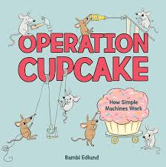

Simple Machines

Complete the following chart using the book: Operation Cupcake

| The Six Simple Machines | Definition | Common Examples |
| --- | --- | --- |
| Inclined Plane | A ramp that helps when moving an object between lower and higher locations. | -ramps  -staircases  -ladders  -conveyor belts  -slides  -mountain roads  -escalators |
| Lever |  |  |
|  | A wheel and a rope that, used together, makes lifting heavy objects easier. |  |
| Wheel and Axle |  | -pizza cutter  -doorknobs  -roller skates  -fans  -rolling pins  -car wheels  -faucets |
|  | A raised ridge wrapped around a cylinder that helps to hold things together or lift and lower an object. |  |
| Wedge |  |  |