IF YOU SEE A BlUEBIRD

BOOKMARKS

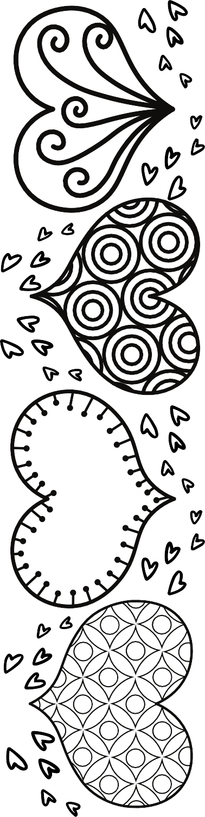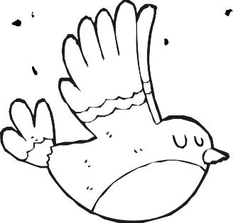

Read

Home

If You See a

Bluebird