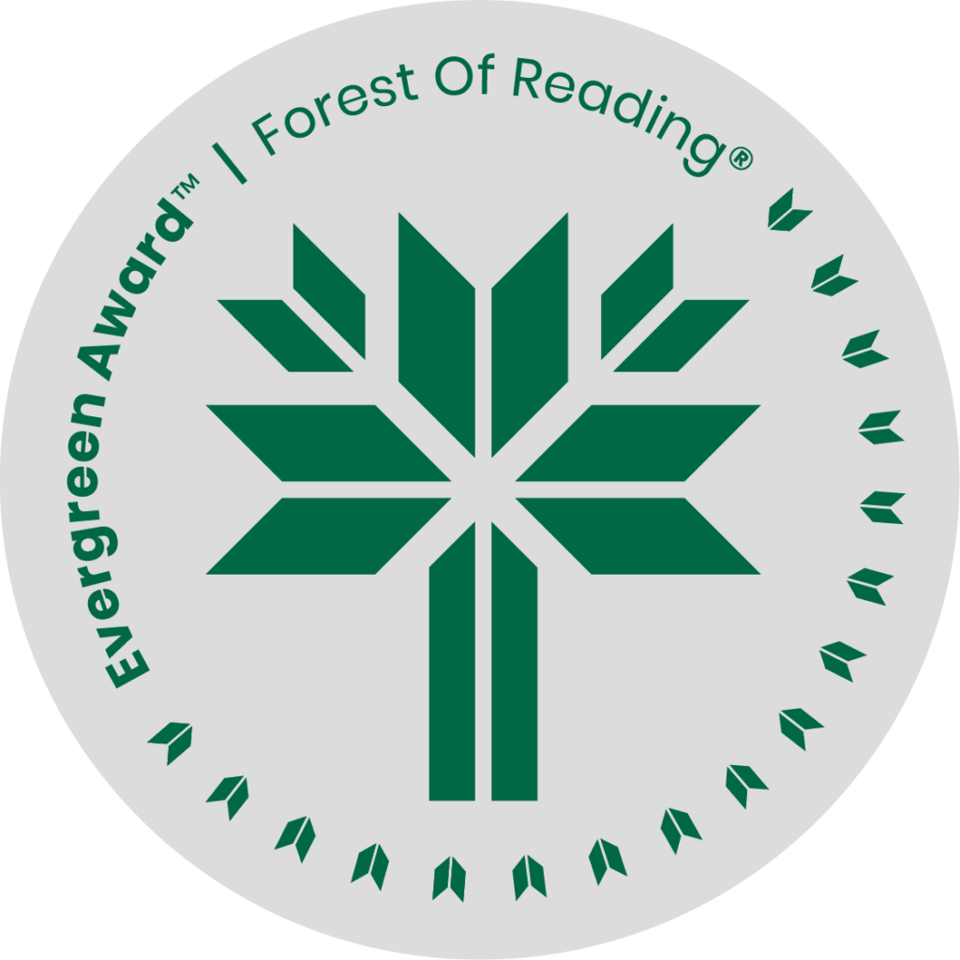

Gin, Turpentine, Pennyroyal, Rue by Christine Higdon

**DISCUSSION QUESTIONS HERE** (Ideally 10 questions to guide discussion of the title):

1. Why did the author choose the words *gin,* *turpentine*, *pennyroyal*, and *rue* for the title of this book?
2. What does the book say about “family”?
3. How did you feel about Llewellyn deeply loving two women?
4. What about Isla? At the beginning, she speaks to the reader: “Maybe you will forgive me. Maybe I will forgive myself. Perhaps there is nothing to forgive.” Should she have asked Morag for forgiveness or kept her secret forever? Could she ever admit to her family the truth about her relationship with Llewellyn without causing a huge rift?
5. The McKenzie siblings’ personalities are all very different. Roddy, their deceased brother, was the eldest. Georgina came next. Isla is the middle child. Morag followed her. And Harriet-Jean is the baby of the family. Do they fit the roles often attributed to “place” in the family?
6. Victor, Georgina’s husband, is a World War I veteran who stutters. We learn some very hard things about him later in the book. Why do you think the author gave Victor such a difficult back story?
7. Flore and Isla agree that Llewellyn’s compulsion for revenge will not solve the bigger picture of the issues women faced in this period. What do you think?
8. Women a hundred years ago had few options for controlling the number of children they had or for safe and legal ways to end an unwanted pregnancy. The author has said that there are echoes and resonances of this period today in many places around the world. What has changed in the past century?
9. How does Padraig, whose father threatened to kill him over his sexual orientation, help Harriet come to terms with hers? Why does he, when he is beaten, blame himself?
10. Llewellyn is about to be a father. Throughout the book, hints are offered as to the character of his estranged parents and how Llewellyn might have been raised. Isla regrets not paying more attention to what Llew had to say about his parents. What can we guess about how they will treat their grandchild?
11. The dog, Rue, is almost a Greek chorus, commenting on the thoughts and actions of the characters in the novel. Did you like what she offered to the story?
12. Isla speaks of the impact Llewellyn had on her: “I don’t know if he gave me hope, but he made me soft. Softer. And yet, what good can come of being soft? Is it akin to preferring the ‘nice’ side of Georgina? Does anything change without the power of anger? I don’t know anymore.” Isla asks herself whether important change can ever be achieved without anger. Is it achievable for the women in the book? Is it different for the men?

Questions sourced from the ECW Book Club Guide

<https://ecwpress.com/blogs/book-clubs/gin-turpentine-pennyroyal-rue-book-club-guide>