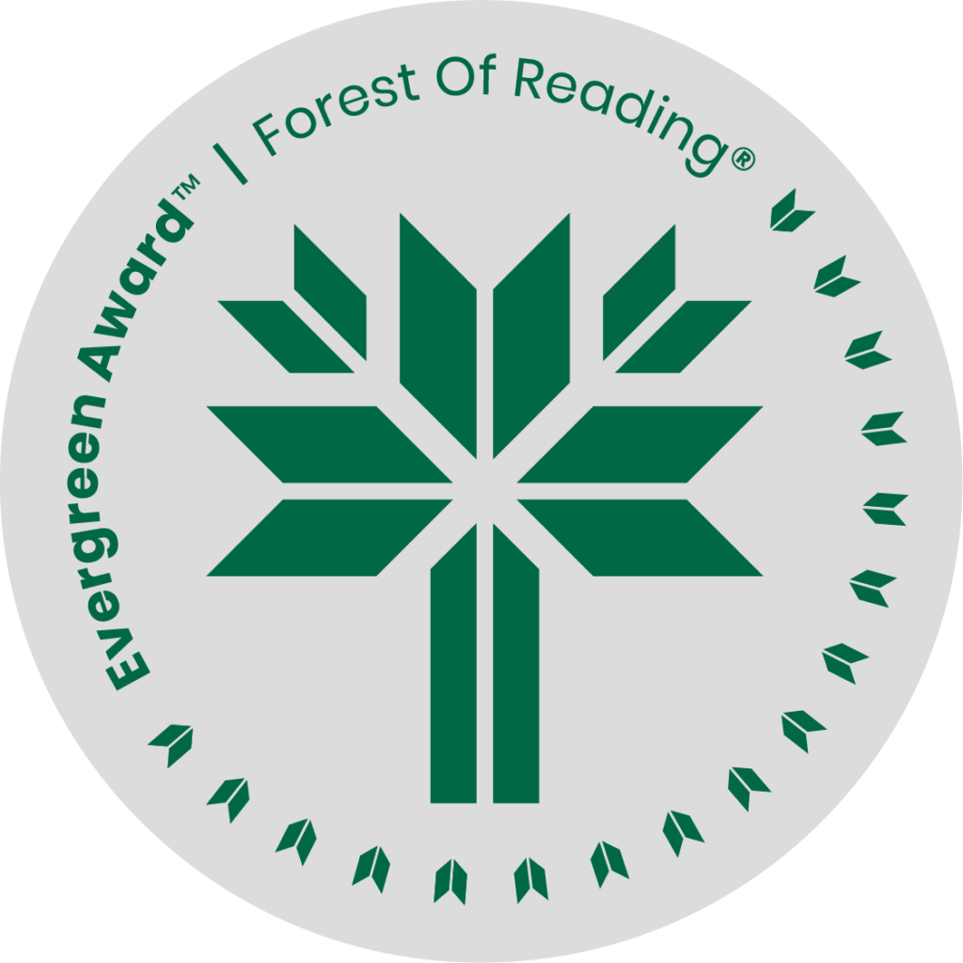

Interesting Facts About Space by Emily Austin

**SHELF TALKER HERE** (Basic elevator pitch - 30 seconds)**:**

Interesting Facts About Space is a quirky, humorous novel about a young woman who is obsessed with space, true crime and has an irrational fear of bald men. While Enid is trying to find balance in her life she believes she is being followed and her paranoia takes over causing her to question her own sanity. She will need to face her fears and feelings to find her way back.

If you liked Interesting Facts you may like:

* Never Been Better by Leanne Toshiko Simpson
* Asking for a Friend by Kerry Clare
* Once Upon an Effing Time by Buffy Cram
* Everyone In This Room Will Someday be Dead by Emily Austin
* Bina by Anakana Schofield