 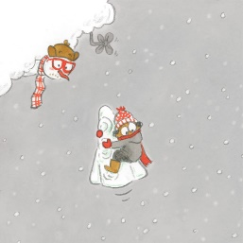

Le Cumulus Machinus

|  |  |  |  |  |  |  |  |  |  |  |  |  |  |  |
| --- | --- | --- | --- | --- | --- | --- | --- | --- | --- | --- | --- | --- | --- | --- |
| M | G | Q | C | N | W | X | E | R | F | T | E | C | Z | D |
| C | A | L | X | O | I | M | H | C | O | E | O | T | H | K |
| R | X | T | K | C | O | J | C | F | U | L | S | B | G | Y |
| I | E | F | H | V | R | J | N | S | L | I | G | F | I | S |
| S | B | G | C | É | N | K | A | V | A | F | P | G | O | F |
| T | E | S | A | O | M | L | R | K | R | Z | E | L | N | G |
| A | S | N | A | U | O | A | B | P | D | O | U | J | K | L |
| L | X | Z | N | P | N | M | T | C | U | M | U | L | U | S |
| L | V | U | E | E | X | B | K | I | O | Z | E | V | X | Y |
| I | Y | T | K | P | T | Z | E | R | Q | K | Q | C | B | A |
| S | T | V | P | M | T | N | T | O | P | U | U | H | P | I |
| E | D | X | S | X | V | S | A | U | F | K | E | E | U | E |
| R | E | I | F | I | R | T | É | P | B | N | O | S | W | D |
| C | E | D | N | A | M | M | O | C | É | L | É | T | V | H |
| U | R | O | Z | Y | W | E | W | W | W | J | L | B | S | U |

ANTENNE BRANCHE CRISTALLISER

CUMULUS FILET FOULARD

MATHÉMATIQUES NUAGE PÉTRIFIER

SALOPETTE STROMULOS TÉLÉCOMMANDE