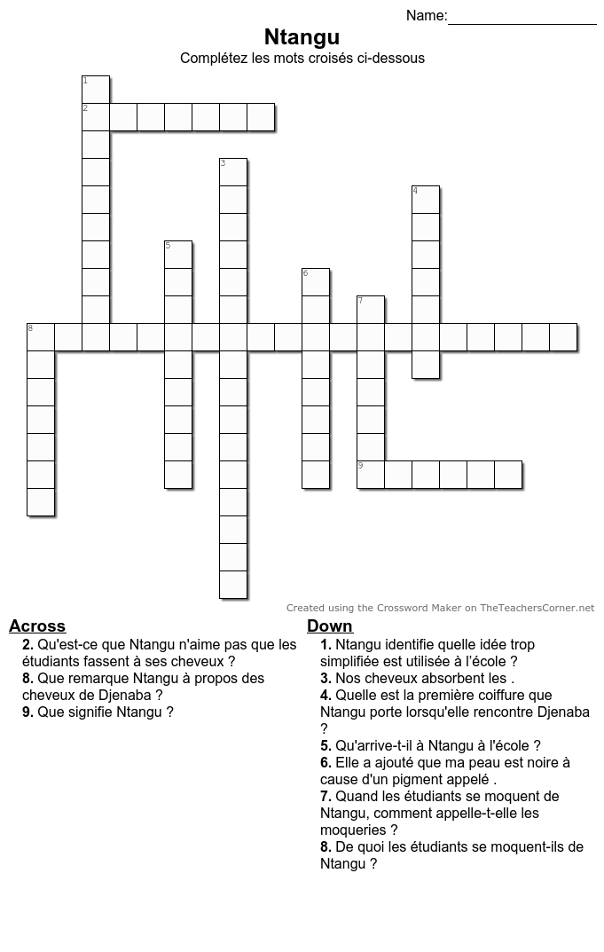

**Nom:**

**Date:**

**Horizontal**

**Vertical**

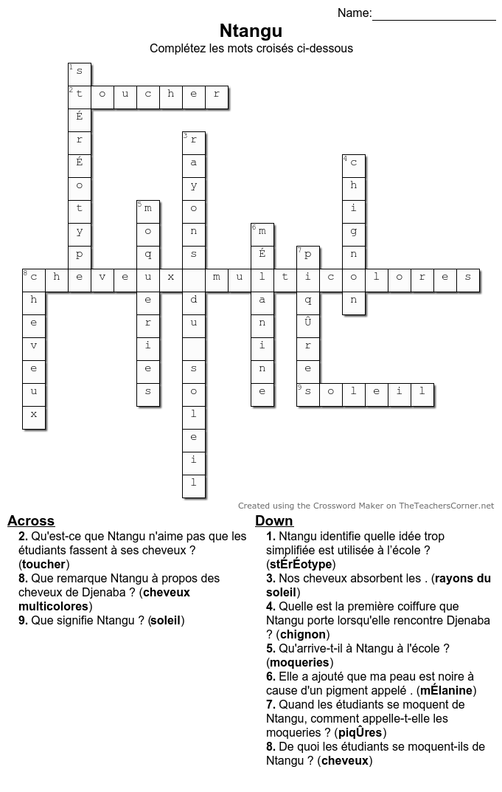

**Vertical**

**Horizontal**

Nom: