 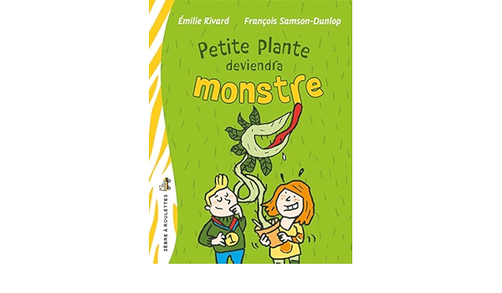

Petite plante deviendra monstre

| Y | E | O | P | K | J | A | B | W | D | S | N | E | V | S |
| --- | --- | --- | --- | --- | --- | --- | --- | --- | --- | --- | --- | --- | --- | --- |
| E | Y | N | H | I | Z | K | B | Q | L | H | O | U | M | P |
| S | N | C | I | A | S | R | Q | E | N | T | I | Q | J | X |
| L | I | I | L | A | K | S | S | L | E | S | D | I | X | O |
| X | T | É | L | Z | M | È | E | R | T | G | Y | S | K | B |
| O | E | G | P | É | H | R | R | N | T | R | Y | U | W | U |
| Q | M | M | Y | T | C | A | E | B | L | A | Q | M | I | I |
| H | U | U | O | Z | R | D | O | G | Q | I | T | G | I | R |
| T | K | P | U | I | Z | I | I | T | S | N | T | C | A | C |
| X | Y | X | U | H | C | Q | J | H | I | E | Q | S | W | R |
| H | E | M | B | H | S | B | K | H | E | S | Z | M | Z | E |
| Z | L | W | Y | Z | Y | V | Z | V | H | X | Z | X | E | L |
| E | S | I | U | I | Y | K | L | H | Q | A | L | R | C | B |
| Q | G | Q | T | C | I | V | O | D | U | L | O | J | I | E |
| C | A | C | T | U | S | E | R | O | V | I | N | R | A | C |

AZALÉE CACTUS CARNIVORE

CÉLINE DION GERMAINE

GRAINES HYPOTHÈSE LUDOVIC

MUSIQUE PISSENLITS TERRARIUM