Cherchez les mots ci-dessous.

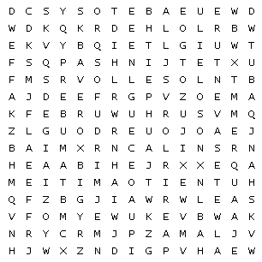

| amitié |  | amour |  | aventure |  |
| --- | --- | --- | --- | --- | --- |
| câlins |  | jeux |  | joie |  |
| jouer |  | Lilou |  | rire |  |
| Soleil |  | souvenirs |  | tendresse |  |

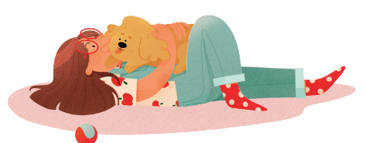

Solution

