| Le prix Peuplier Award Logo Nom: __________________ |
| --- |
| Mots cachés |

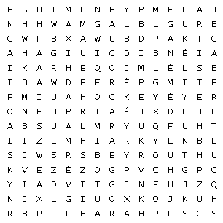

| arabe |  | ar  artiste | | |  | Beyrouth |  |
| --- | --- | --- | --- | --- | --- | --- | --- |
| chawarma |  | culture | | |  | déménage |  |
| Désirée |  | Éli | | |  | habibi |  |
| hockey |  | Labaki | | |  | Liban |  |
| mariage |  | père | | |  | pluie |  |
| Le prix Peuplier Award Logo | | | Nom: |  | | | |
| Mots cachés - corrigé | | | | | | | |

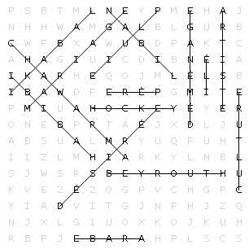

| arabe |  | artiste |  | Beyrouth |  |
| --- | --- | --- | --- | --- | --- |
| chawarma |  | culture |  | déménage |  |
| Désirée |  | Éli |  | habibi |  |
| hockey |  | Labaki |  | Liban |  |
| mariage |  | père |  | pluie |  |