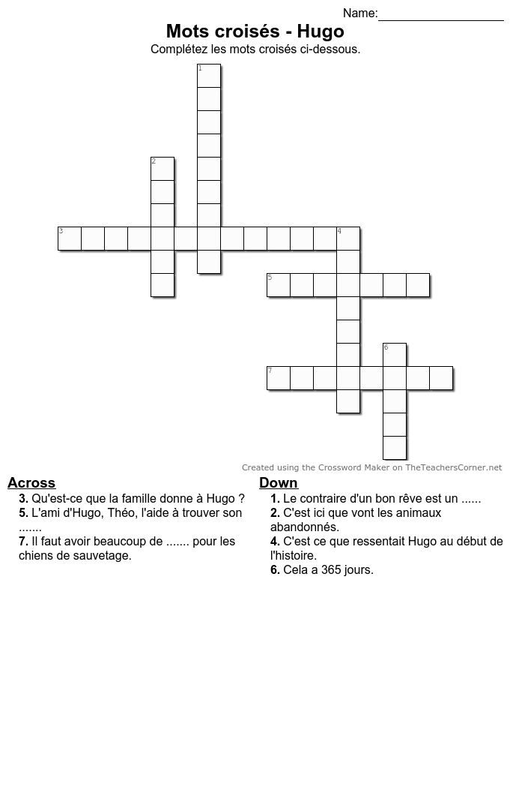

**Vertical**

**Horizontal**

Nom:

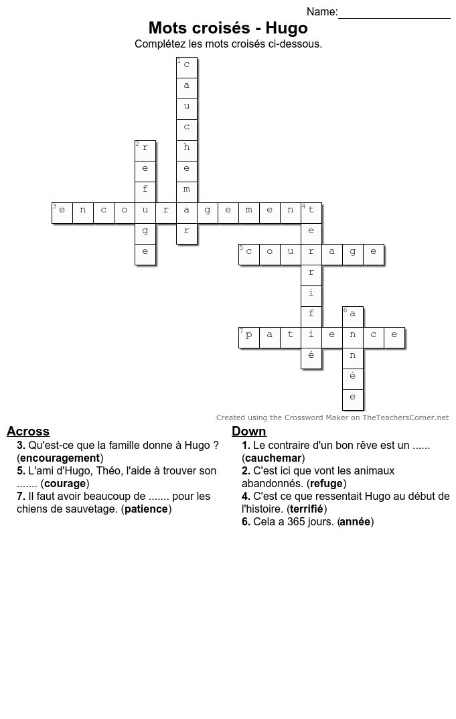

Nom:

**Horizontal**

**Vertical**