 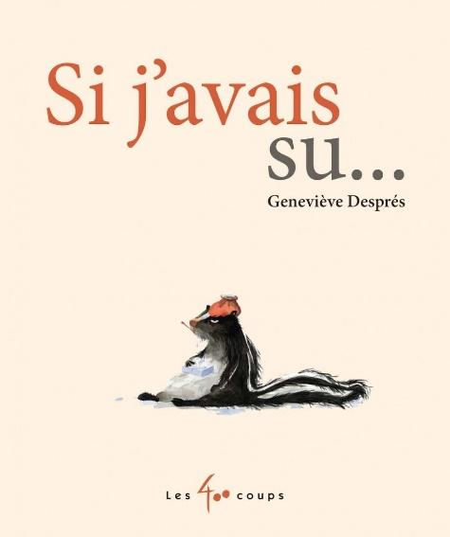

Si j’avais su…

| S | L | U | D | F | A | E | V | W | E | G | R | C | C | T |
| --- | --- | --- | --- | --- | --- | --- | --- | --- | --- | --- | --- | --- | --- | --- |
| G | B | O | Q | X | J | H | T | V | E | J | E | O | A | N |
| V | C | L | U | G | T | Z | È | T | C | R | Q | X | S | E |
| N | X | N | E | P | H | I | I | R | E | Z | L | C | T | D |
| B | D | O | U | S | V | N | A | L | É | F | Q | X | O | I |
| I | N | D | O | E | S | N | Z | O | G | E | U | N | R | C |
| A | M | A | N | N | O | U | A | X | A | B | I | O | D | C |
| S | E | E | S | Q | O | Q | R | O | X | P | L | Q | M | A |
| D | G | E | G | E | R | Z | O | E | A | U | I | V | G | N |
| G | S | C | W | E | N | G | N | L | X | G | U | P | A | Q |
| K | W | L | N | H | P | I | Z | K | S | A | E | X | D | C |
| L | B | A | D | E | S | P | R | È | S | A | R | Y | N | F |
| L | R | X | N | L | C | Y | Y | I | W | N | U | C | Z | A |
| D | G | X | C | X | B | U | Y | F | R | G | C | Q | O | Q |
| O | M | O | U | R | S | X | K | A | X | R | É | V | T | W |

ACCIDENT BLESSURE CASTOR

DESPRES ÉCUREUIL ÉLAN

GENEVIÈVE LAPIN LOUP

MOUFETTE OURS RENARD