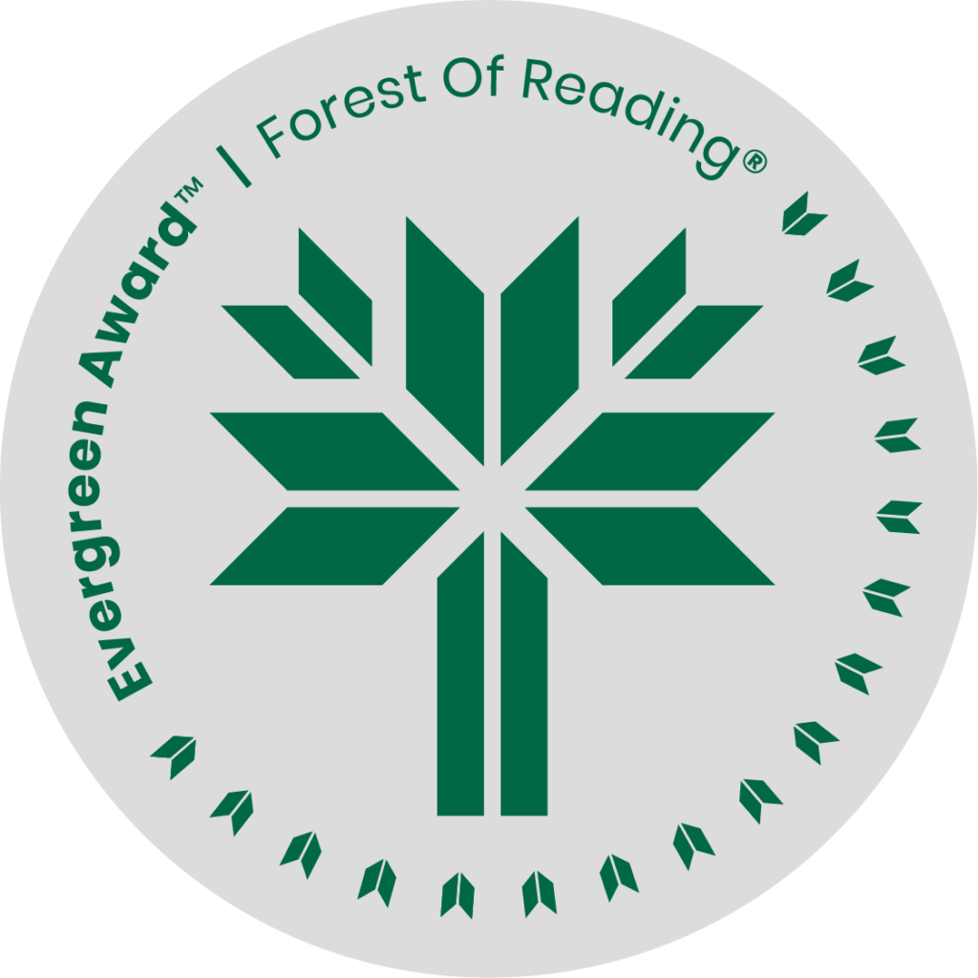

Landbridge by Y-Dang Troeung

**DISCUSSION QUESTIONS HERE** (Ideally 10 questions to guide discussion of the title):

1. What was the intent or objective of this book?
2. How much did you know about the Cambodian genocide prior to reading this title? Consider why that is so. What did you learn while reading this title?
3. The author was an academic - do you think the writing comes across as overly scholarly? Why or why not?
4. This memoir centered around the refugee experience coming to Canada. Did it change the way you think about refugees and how they are treated in our Country?
5. Troeung included letters to her son, interspersing them within the text. How did you feel about them? Did the letters add, or detract, from her story?
6. The book is sub-titled “a life in fragments.” How did you feel about the fragmented format of the book? Did it keep you engaged, or throw you off?
7. Was there any specific section of the book that had a particular impact on you? Share parts of that section and its impact.
8. This is a memoir, but also includes the history of the author’s family and their life in Cambodia before she was born. Discuss how the addition of this history enhanced your reading experience.