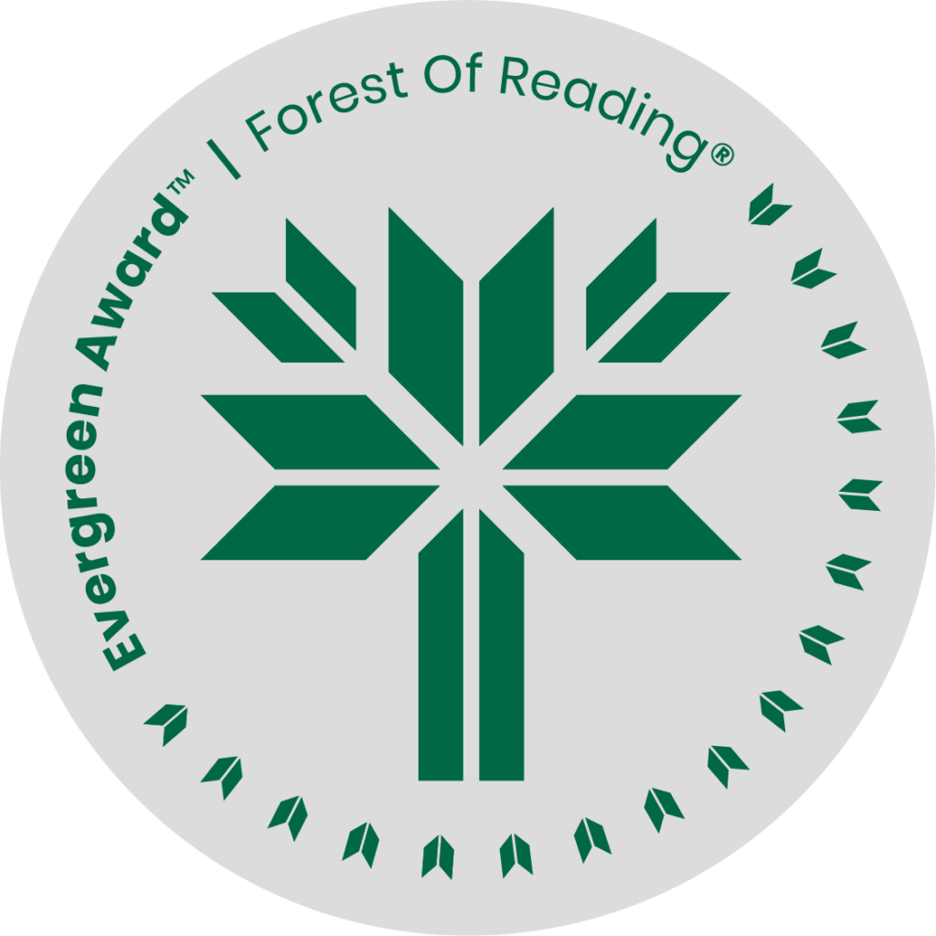

Landbridge by Y-Dang Troeung

**SHELF TALKER HERE** (Basic elevator pitch - 30 seconds)**:**

Landbridge is a memoir in fragments. It centers around Troeung's family's refugee story with a mix of anger, humour, sadness and frankness. The discussions around hereditary trauma, and how the world takes claim over Cambodia's history is fascinating and thought provoking. This is a book that will stay with the reader, and keep them thinking, for a long time.

If you liked Landbridge you may like:

* Scratching River by Michelle Porter
* There Is No Blue by Martha Baillie
* Matryoshka Memoirs, The: A Story of Ukrainian Forced Labour, the Leica Camera Factory, and Nazi Resistance by Sasha Colby
* Like Every Form of Love by Padma Viswanathan
* When My Ghost Sings: A Memoir of Stroke, Recovery and Transformation by Tara Sidhoo Fraser