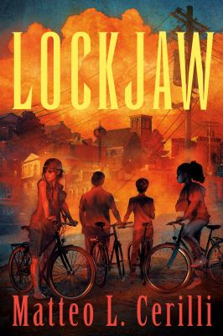 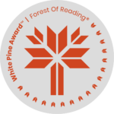Lockjaw

Activity #2 – Art Activity

A collage is an art piece that is made by collecting objects of different materials, such as photographs, drawings, or fabric, and gluing them to a backing. A collage can also be used to portray a message or a theme. Collages can also be made digitally, using photographs or drawings.

Using materials available to you, create a collage for the novel *“Lockjaw”* that would provide someone who has never read the novel an idea of what the novel is about. Think about what aspects of the novel you would want to portray. Would you focus on characters, plot, or both? You can do this in groups, pairs, or alone.

**Alternative option:** Booktok is the use of TikTok videos to promote or discuss books. Create a short (thirty seconds to one minute) video to promote *“Lockjaw”*  to a potential reader who hasn’t read it yet. Similar to the collage, think about what aspects of the novel you would want to portray, and how you would talk about the book without giving any spoilers away. Share the video with your group (but no need to post it publically).