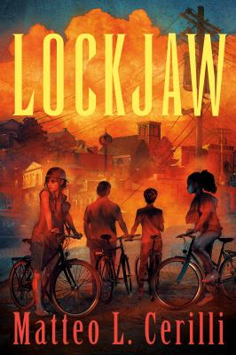 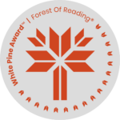Lockjaw

Activity #3 – Community Activity

*“This is Bridlington. We mind our own business.”* So says Beetle (pg. 232), but this phrase is repeated over and over throughout the book by many characters. In some ways, it seems to be the town’s motto. This is the mentality that Paz tries to fight against.

In the author’s note, Matteo Cerilli, talks about how writing this book was his search for community. Compare the character of Bridlington from the first chapter, when the reader is first introduced to the town, to the epilogue. What is different? What has changed? What has stayed the same? Do you feel Bridlington has become a community by the end of the story?

In pairs, or groups, discuss what makes a community a community. What makes you feel welcome in your own community? Is there anything that makes you feel unwelcome? Record your suggestions and ideas and compare them to others. Did you come up with similar answers?