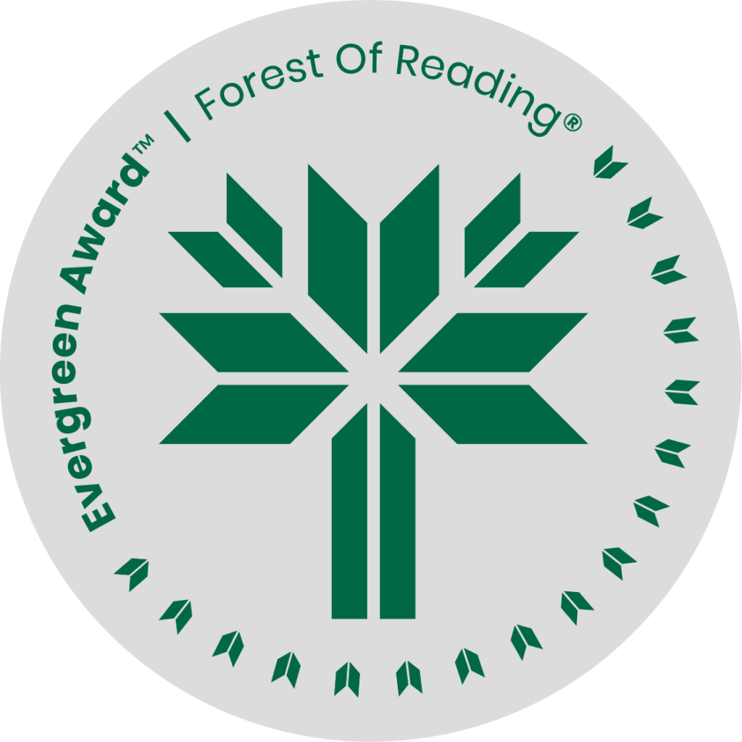

North of Nowhere: Song of a Truth and Reconciliation Commissioner by Marie Wilson

**SHELF TALKER HERE** (Basic elevator pitch - 30 seconds)**:**

From behind the scenes of the Truth and Reconciliation Commission, Marie Wilson shares her first hand experiences bearing witness to those affected by the residential school system and other government funded institutions. She brings us her own unique understanding and also challenges the lens through which most Canadians view this shared history.

If you liked North of Nowhere you may like:

* Unreconciled: Family, Truth and Indigenous Resistance by Jesse Wente
* All Our Relations by Tanya Talaga
* Five Little Indians by Michelle Good
* Indian Horse by Richard Wagamese
* Peace Pipe Dreams: The Truth About Lies About Indians by Darrell Dennis
* 21 Things You May Not Know About the Indian Act: Helping Canadian Make Reconciliation with Indigenous Peoples a Reality by Bob Joseph
* The Inconvenient Indian: A Curious Account of Native People in North America by Thomas King