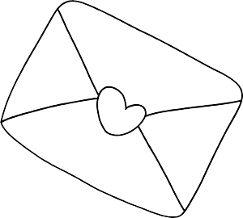Name: ________________

Postcard Art!

Design a postcard for someone you love to tell them about your day. Draw or write about the best part of your day.