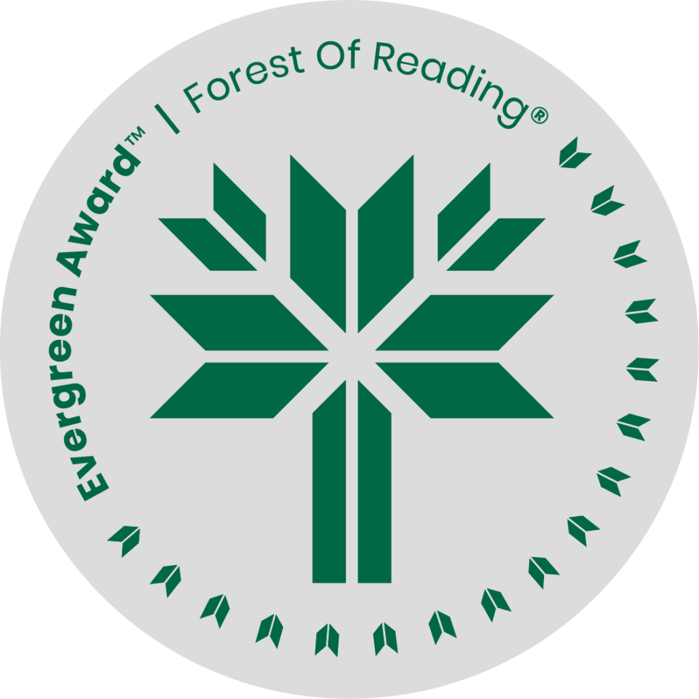

Roar by Shelley Thompson

**SHELF TALKER HERE** (Basic elevator pitch - 30 seconds)**:**

Following her mother’s death, Dawn, a trans woman, returns to her family’s farm and rural hometown for the first time post-transition. Written with realism and tenderness, this novel tells a story of grief, love, acceptance, hope, and the importance of home, community and identity.

If you liked Roar you may like:

* The Way Back Home by Allan Stratton
* One in Every Crowd by Ivan Coyote
* Johnny Appleseed by Joshua Whitehead
* Valid: Dystopian Autofiction by Chris Bergeron, Translated by Natalie Hero
* My Body is Distant by Paige Maylott
* One Sunny Afternoon by Rowan Jette Knox