**The Longest Shot - Create a Poster** 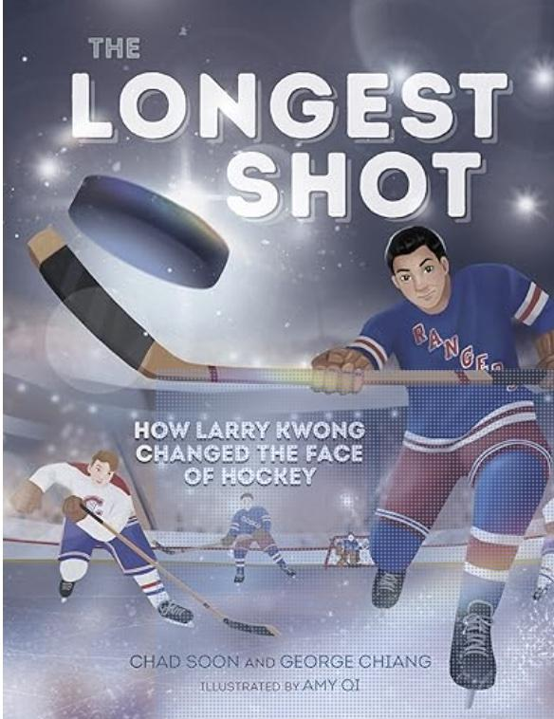

Create a poster to cheer Larry on at his first game in the NHL at Madison Square Garden.

