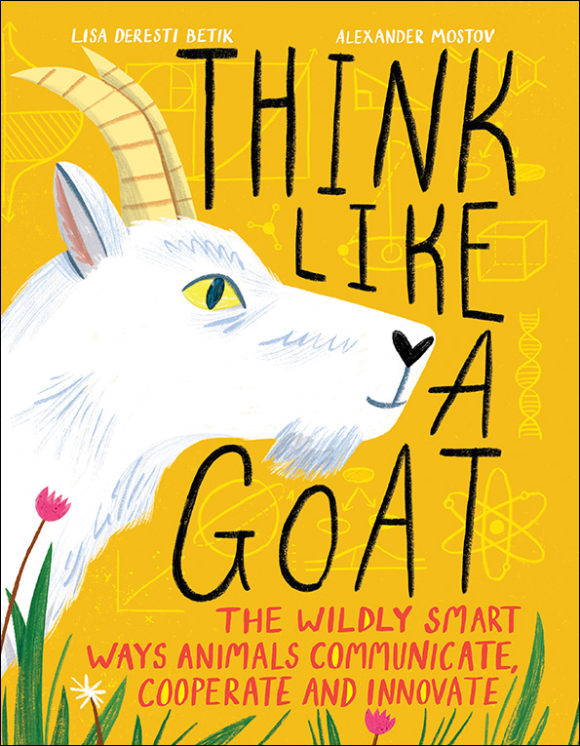**Name __________________________________**

**THNIK LIKE A GOAT**

Word Search

| A | L | G | O | R | I | T | H | M | I | O | N |
| --- | --- | --- | --- | --- | --- | --- | --- | --- | --- | --- | --- |
| E | V | U | L | T | R | A | S | O | N | I | C |
| I | N | T | E | L | L | I | G | E | N | C | E |
| N | E | E | E | V | O | L | U | T | I | O | N |
| S | U | C | E | M | P | R | C | R | A | M | A |
| T | R | E | C | E | P | T | O | R | N | M | G |
| I | O | P | R | I | T | T | V | K | T | U | O |
| N | N | P | D | A | R | W | I | N | H | S | G |
| C | N | L | I | Z | A | R | D | C | R | P | O |
| T | E | P | A | H | U | B | E | P | O | A | W |
| L | U | H | L | B | C | C | C | R | P | C | E |
| G | R | M | E | M | O | R | Y | E | O | I | T |
| I | O |  | C | E | Y | O | O | D | L | A | H |
| S | N | P | T | V | O | W | S | A | O | L | J |
| T | X | G | O | A | T | I | N | T | G | N | T |
| H | U | M | A | N | E | B | Z | O | I | H | R |
|  | E | M | P | A | T | H | Y | R | S | U | A |
| E | T | H | O | L | O | G | I | S | T | M | S |
| M | H | P | H | E | R | O | M | O | N | E | S |

Words

etholgist algorithm Darwin communication human

anthropologist memory dialect ultrasonic predator

neurons intelligence social pheromones receptor

instinct crow evolution lizard goat empathy