**Name _____________________________** 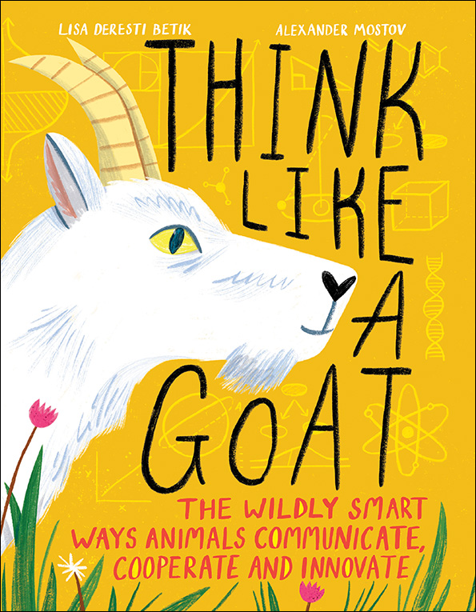

**THINK LIKE A GOAT**

Create a Cartoon

In THINK LIKE A GOAT, the author explores different ways that animals communicate.

Imagine you could create a new improved human with some of these powers of communication: Visual, Auditory, Tactile or Chemical

Draw or use digital graphics to illustrate your new improved humans communicating. e.g. You might choose a human who communicates like a firefly with flashing lights. 