**Name _____________________________** 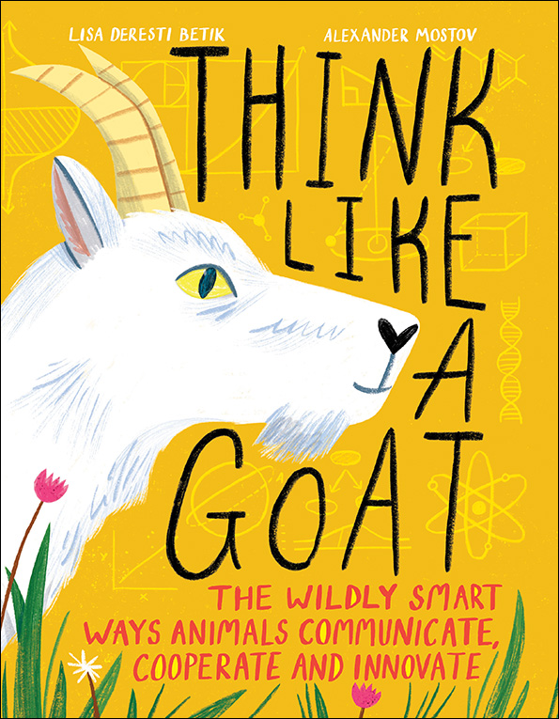

**THINK LIKE A GOAT**

Labelled Diagram

Imagine if you had CRITTER abilities.

Draw an action picture of a CRITTER version of yourself.

Label your CRITTER skills. e.g. Octopus arms that can think for themselves.

