**Name _____________________________** 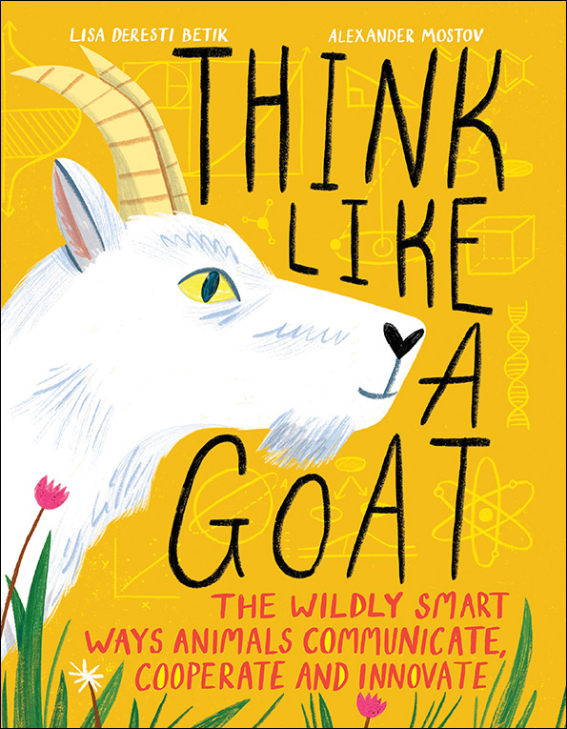

**THINK LIKE A GOAT**

Discussion Questions

**Before Reading**

-Look at the cover of the book. What do you see?

-What does a Goat think about? How does GOAT thinking compare to human thinking?

-Look at the Table on Contents page. What do you think you might learn about in this book?

**During Reading**

Always Evolving: What do ethologists study?

Would you like to have a career as an ethodogist? Why or why not?

Critter Communication: What are different ways that critter’s communicate?

How are these methods of communication different from the ways humans communicate?

Better Together: Describe the ways that 3 different animals work together? What do you think that humans can learn from each of these animals?

Problem Solved: What strategies do mice & tortoises use to navigate mazes?

Do you think either of these strategies could help you navigate a maze?

Mixed Emotions: How do animals show different emotions like empathy, caring and grief?

Are any of these the same as human expressions of emotion?

**After Reading**

-What is one animal ability you are surprised is actually real?

-What type of animal abilities do you hope humans can learn to emulate?

-Do you think it will happen someday in the future?