**Name _____________________________** 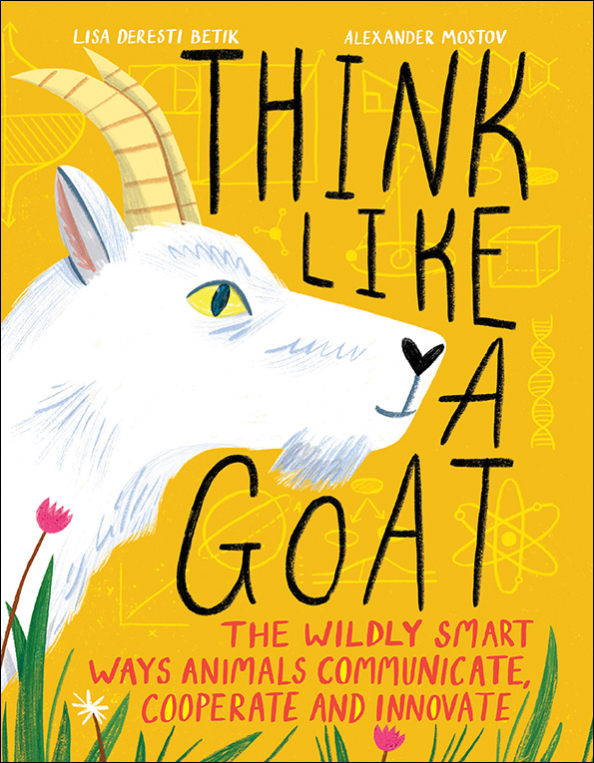

**THINK LIKE A GOAT**

Dramatic Activity

1.Select a partner or small group. ___________________________

2.Choose 2 CRITTERS whose communication abilities you find interesting.

__________________________ ________________________

__________________________ ________________________

3.Write a brief conversation between the 2 CRITTERS in English.

e.g. DOLPHIN → DOG “How are you?” →“I feel great!”

_________________________________________________

_________________________________________________

_________________________________________________

_________________________________________________

_________________________________________________

_________________________________________________

3.Translate the conversation into CRITTER, rehearse and perform for your classmates. Use simple costumes/props so that your audience can recognize which CRITTERS you and your partner represent. Have fun!