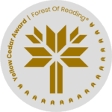 ***Welcome to AI* - Creative Activity** 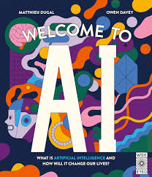

**Draw a picture or write a story about how you think AI will impact the world in the future.**













































