 ***Welcome to AI* - Discussion Questions 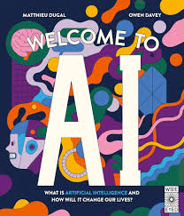**

1. Give an example from history of an object that appeared to move and think for itself.
2. When and how was the term “robot” first used? What does the Czech term “robot” mean?
3. How did Marvin Lee Minsky define artificial intelligence in 1956?
4. What is the “Imitation Game” invented by Alan Turing?
5. Why is human intelligence superior to artificial intelligence?
6. What does AI need in order to work?
7. Give an example of machine learning.
8. What is GPT-3? Name some other things that can be created with AI.
9. Give an example of a “deepfake”
10. What are avatars and how can they be used by AI?
11. What are some of the problems with AI?
12. Can you think of some possibilities of how AI might be used in the future?