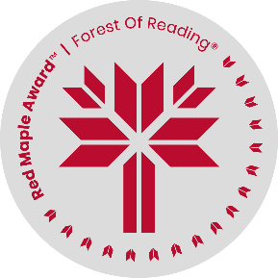
Red Maple Activity: Language Activity
The Time Keeper by Meagan Mahoney

Name: ______________________________

“Remember, ‘tis a sair ficht for half a loaf.” (Page 253)
Miss McCardle speaks many phrases throughout the book in Scots, a regional language in Scotland. Below are some words and phrases in Scots. Can you find the English translation?

Scots
- Lang may yer lum reek
- Ah dinnae ken
- It’s a dreich day
- Scran
- Am pure done in
- Clatty
- Haver
- Eachy-peachy
- Stauchie
- Cairryin water tae a fou sea

English
- Food
- Making things worse
- The weather is miserable
- Lie
- Humid
- I am very tired
- Disgusting
- A wish for a long and healthy life
- Equal or balanced
- I don’t know

