The Great Dinosaur Sleepover

Find the words listed below
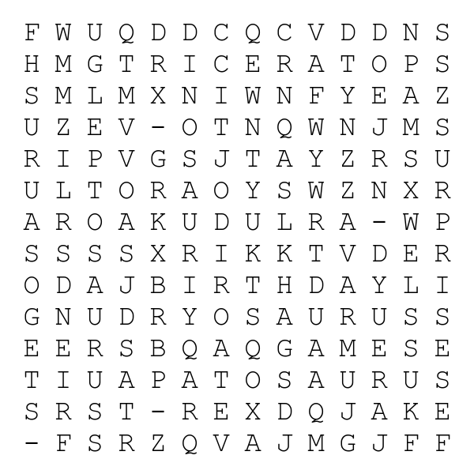
Jake Friends Games Stegosaurus
Dinosaur Birthday Surprise Dryosaurus
Leptosaurus T-Rex Apatosaurus Triceratops
Solution:
